Easy Read – Incident Management
What is an incident and how is it managed?

 | This document tells you what an incident is and how Compassion SA manages them.
There are two types:
- A general incident
- A reportable incident.

A general incident is:
- When a person causes you harm or could have caused you harm
- when you hurt someone else
- when you feel that someone is going to hurt you.
A reportable incident is when one of the following happens:
- a death
- a serious injury
- abuse
- neglect
- sexual misconduct
- unregulated use of restrictive practices.
 | If you are involved in an incident you must tell our General Manager, your support worker or a trusted person immediately.
 | Our General Manager will meet with you to record what was said and done during the incident.
Our General Manager will ask you:
- what happened
- the names of people who saw the incident
- when you told someone about the incident (date and time)
- details of the person you told
- how the incident affected you
- what could be done to stop the incident happening again.
Your safety is important to us.

After an incident we will provide support or assistance to help you recover from the incident.

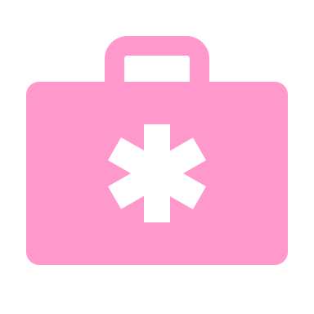 | After an incident, Compassion Sa will:  - do all we can to make sure you are safe  - provide you with advice and support  - arrange for counselling or medical support (if required).
We will support you by:
- fixing the incident quickly
- helping you look after your health and wellbeing (where we can).

 | We will regularly keep you up to date with how we are managing the incident.
The General Manager will contact you to:
- talk about what happened
- tell you what actions we will take to fix the incident
- explain to you what actions have already been taken.

We will ask for your:
- feedback and thoughts on how we are fixing the problem
- ideas about any changes that could help you in the future.

 | Our General Manager investigates the incident to work out what happened and stop it happening again.
We then complete a review of the incident to improve our service by:
- learning what happened
- making changes to stop it happening again.

Some changes we might make could be to:
- change our practices
- change our policies
- retrain our staff.

 | Reportable incidents
 | A reportable incident is when you, or another participant, is very badly hurt or mistreated.
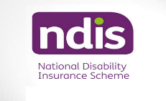 | If a reportable incident happens Compassion SA must tell the NDIS Commission.
We must complete an NDIS Reportable Incident Form. Either the:
- Immediate Notification Form
- 5-Day Notification Form.
 | Compassion SA then must send the form to the NDIS Commission using the NDIS portal.
The NDIS Commission reviews the incident.
They will tell us if we need to take any further action.

 | We will update you on the NDIS Commission’s findings including any actions we must take.
 | We keep everything you tell us private.
If you are unhappy with the way we handled your incident, you can tell the NDIS Commission:
- Call: 1800 03 55 44 (free call from a landline)
- Go to their website: www.discommission.gov.au

